S-Web 6 VC🚀 AI-CMS -
The SMF for Sir Richard Branson
20.16z27b] S-Web 6 VC🚀 AI-CMS - The SMF for Sir Richard Branson [13 Jan 2024]
By Nick Ray Ball

S-Web 6 VC🚀 AI-CMS - The SMF for Sir Richard Branson started its life as a follow-up to Economic AI – S-World – All COMMs (18 Oct 2023) which was destined to be the introductory document for Stage 10. S-World HEAI for Nicole Forsgren. ☆DF62
The original purpose of the document was to present many facets of S Web to Sir Richard Branson and Virgin Group, However, this document ended up as a specialisation on the T3 (Technology 3) SWF Swapping Menus Function. And in the six months that have followed the T3 SMF is now king of the parade. So much so when we look at stage 1. The Quanta Analytica, that ingeniously pays software engineers and creatives royalties. I’m advising everybody if they want to engineer one thing and get royalties for it for the rest of their lives it’s the T3 Swapping Menus Function.
In the original article found below, we hear about how, when we added an S-Web menu selection from Experience Africa, onto the CapeVillas website when a client from Michigan asked about safaris the booking request came to Experience Africa and after the $100,000 booking was complete Cape Villas was paid $10,000 for the referral in affiliate commission. In a deal, Experience Africa would love to make again and again.
I had forgotten at the time, at least consciously, that the biggest part of the prototype booking was Sir Richard Branson’s Private Game Reserve Ulusaba via Virgin Limited Edition. This is of course fortuitous, because I was worried people would think it would be just too good to be true, whereas in this case, Virgin Limited Edition can check the booking against the name Villa Secrets for due diligence on this claim. I mean just making $10,000 for having somebody else’s menu loaded into your menu, that sounds far too good to be true.
The Web 6 VC🚀 AI-CMS - The SMF for Sir Richard Branson.
Originally written on Jan 13, 2024.

Three months after writing this I began the ☆DF podcast series for David Farley the author of Modern Software Engineering, in part because repetitive strain from a laid position causes severe pain in my shoulder, and I needed to use audio recordings as a form of presentation. This is an entirely different discipline from working with your hands, which helped crystalline the process, however, it is not complete. But as I keep telling myself perfect is the enemy of nearly perfect, it may not be in order but everything is there.
To follow the presentation of the podcast please go to the 🌊S-Web 2024 ☆DF menu on www.s-web.org
Username: VIRGIN
Password: Galactic

In my TBS-CC-OKRs Q-Planner Stage 11) VIRGIN 2011 & 2024. I planned to tell of the adventure in 2011 and show this document, before presenting the podcast via the S-Web.org menu. But I’m getting more and more neurotic about the non-scripted podcast, it may be a while before I get to stage 11. So, for now, I have added the following as an introduction.
- The plan for Sir Richard in 2011.
https://www.s-world.biz/TST/The_Virgin_Business_plan_in_Retrospect.htm
Pre “Spartan Theory” Chapter 1
"The Virgin Business Plan"
Executive Summary
18th March 2011
https://www.s-world.biz/TST/The_Virgin_Business_plan_in_Retrospect.htm

There is much to say about the 440,000 words of www.s-world.biz in 2011 that followed this plan, and how that, in turn, inspired AmericanButterfly.org in 2012. and there is much to say about the Libya incident, which saw me spectacularly blow the opportunity in 2011.
I have created this as a book and screenplay called The Way Back. The third version of the screenplay goes by the title The Virgin Martha Mitchell Effect. It is very detailed, it has riveting hooks, and I hope will become the perfect marketing product placement vehicle that turns S-Web 6VC ‘Sienna’ AI CMS into a global brand.

But for now, I’d like to go back a few years before 2011 and the Sienna Software Executive Summary and tell of the run-up to the Virgin Presentation and how that led to the CRM Nudge AI design in 2017 and the CRM Nudge AI design that is my current design focus at this time.

For this, we must migrate from the UK to Cape Town.
On the 2nd of August 2008, I woke from a dream about Sir Richard and the game idea I had previously considered called Villa Mogul. I can't say if I bought Sir Richard’s book before or after the dream but what is for sure is that the cutting-edge work in S-Web design right now is the entangled CRM Nudge AI and if not for Sir Richard’s book introducing me to branding, it would not exist.
After reading his book as best I could with my dyslexic style I wanted to know more so I attended some lectures on branding and took my staff to ‘Enlighten’ branding camps where amongst other activities we wrote on post-it notes how we could improve customer service, stuck them on the whiteboard and then brainstormed.
One such note suggested giving guests gifts, which was useful as Bulgari wanted to barter the inside cover on our next Conde Nast Distributed Magazine for $100,000 in Bulgari merchandise. This inspired the CRM guest gifts idea in the Sienna Software design I presented to Fiona Ross in 2011. https://www.s-world.biz/TST/The_Virgin_Business_plan_in_Retrospect.htm
The function below was for our agents to send gifts to their clients.
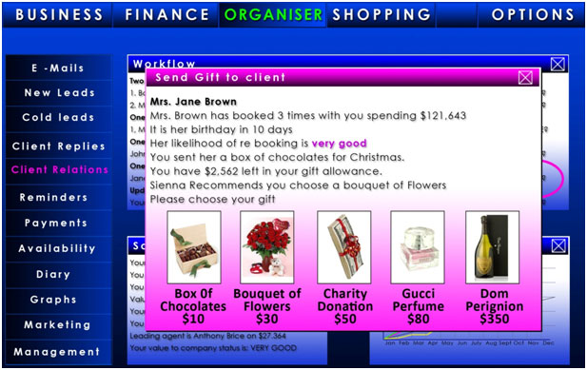

A year later ‘guests gifts’ had been reimagined for Facebook as an entry to e-commerce on http://americanbutterfly.org/pt1/the-theory-of-every-business/ch6-facebook-business-development/facebook-gifts
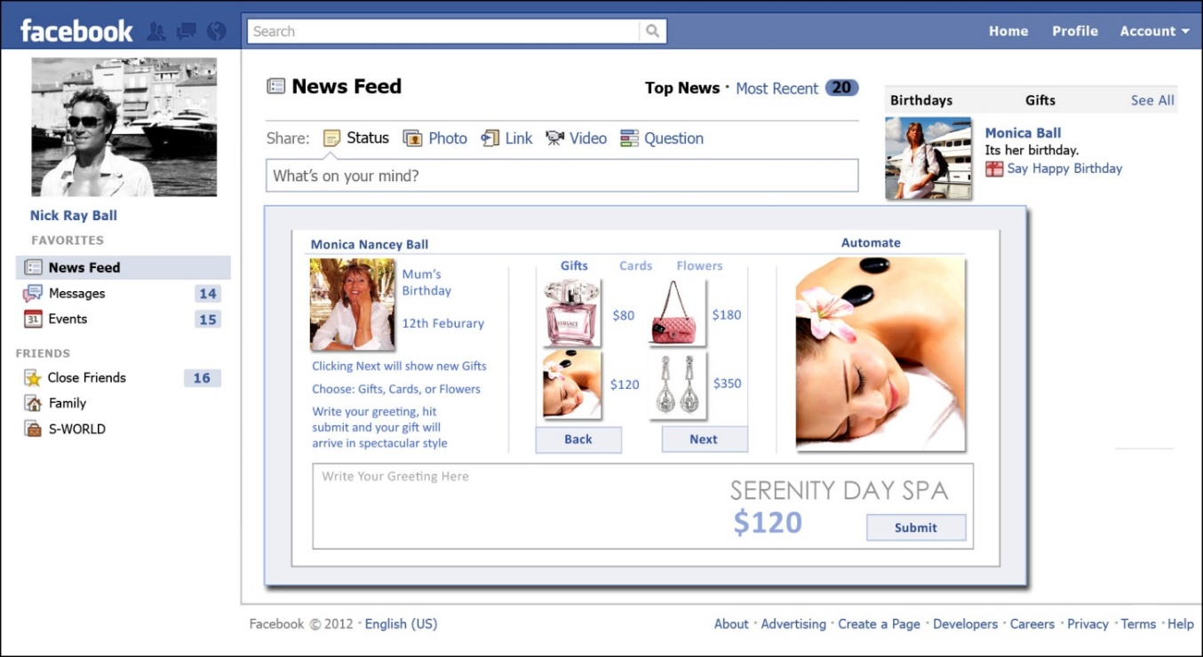

Below we see the luxury version noting that Virgin Galactic was one of the options.
http://americanbutterfly.org/pt1/the-theory-of-every-business/ch6-facebook-business-development/lx

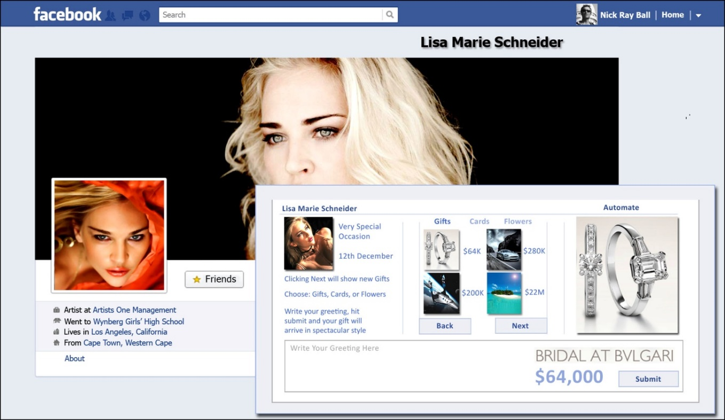

This concept for Facebook is entangled within future designs and in many ways, you can say it has now been adapted to Instagram. As seen below

The above designs from 2011 and 2012 continued development to a specific chapter in my 2017 book The Villa Secrets’ Secret chapter 6. The CRM Nudge AI. http://network.villasecrets.com/the-secret/ch6/crm-nudge-ai. This work has now become entangled within the S-Web 6 design and the SMF which itself can trace its engineering back to the My List My Website functionality within S-Web 4.

I would continue if not for the pain in my arm, so we shall jump back to July 2024 and the ☆DF ‘David Farley’ Modern Software Engineering 2024 Podcast. That is currently best presented on the 🌊 S-Web 2024 menu on www.s-web.org
Username: VIRGIN
Password: Galactic
https://podcasters.spotify.com/pod/show/nickrayball
I suggest starting with ☆DF18 For Effective Altruists Everywhere

I am here we only need to edit the following or remove it if necessary.

- Read the presentation below from January 2024 about which the most significant update in Q1 and Q2 2024 is that when you hear me talk about websites, S-Web 6 also creates apps.
Back in January 2024 I had not worked out how to apply navigation to apps and was not sure the engineering was possible within the target budget.
Recently it has become obvious that that SMF can work in apps despite them having no menu to swap. This riddle has been solved as a result of Sienna AI knowing all the menu items, so can discuss with the user and jump from one user’s goods (say Virgin Galactic) to another user’s goods (any other company using Sienna AI) for Apps as well as websites.
The menu system (the SMF) is simply within the AI training data! Again and again, indeed by the end, the AI will be generating this menu for us, it will become a memory system within each AI, created out of the network of the user's repeated entangled SMF keywords and prompts. GPT now asks if one wishes to make each conversation searchable! That’s the new SEO and SEM frontier, that’s the new frontier of Advertising.
This poses the question: Remembering AI is also in TV which of the 5 major AIs will be the king of search and advertising in 10, 20 and 30 years – That’s a dynamic comparative advantage question.
This is already solved as we plan to A B C D E test and deploy Sienna AI using
  - Microsoft Asure & GPT
  - Google Cloud, Google AI and Google Vertex
  - Meta Cloud and Llama
  - Amazon AWS
  - Apple
Creating the same product design 5 times, so no matter which AI dominates the future of search, the companies in the SMF will always be represented.

Saturday – 16:16 GMT – Jan 13, 2024
https://chat.openai.com/share/5d0bed09-2fe3-4969-8388-a2901688fcbf

The Speech Begins:

In the UK's technological landscape, it appears there's a notable absence of companies solely dedicated to developing original AI technologies. Instead, the trend leans towards leveraging the AI platforms created by global tech giants like Google, Meta, Open AI, Microsoft, and the soon-to-be entrant, Amazon. This approach, akin to setting up a temporary structure on established grounds, reflects a broader pattern in our tech industry. The situation begs the question of true innovation and collaboration within the UK's AI sector. While UK companies are adept at utilizing these existing AI platforms, the emergence of a homegrown, pure AI company remains a rarity. This scenario opens up a dialogue about the potential for collaboration and integration through a microservices modern software engineering framework, which could provide a more flexible and inclusive approach to working with diverse AI technologies.
In the UK, the trend in web development mirrors the broader tech sector's approach to AI. Rather than building custom Content Management Systems (CMS) from the ground up, many opt to use WordPress, a ready-made platform, for website design. This is akin to a coachwork shop crafting a limousine from existing car frames, rather than manufacturing new cars from scratch. This analogy highlights a pattern in the UK's tech industry: a preference for modifying and adapting existing frameworks over creating entirely new ones.

"So, are we creating an actual AI? Our journey with the S-World ASI and its 10 Technologies Design points to a more nuanced endeavour.

The 10 Technologies – Microservices – Modern Software Engineering
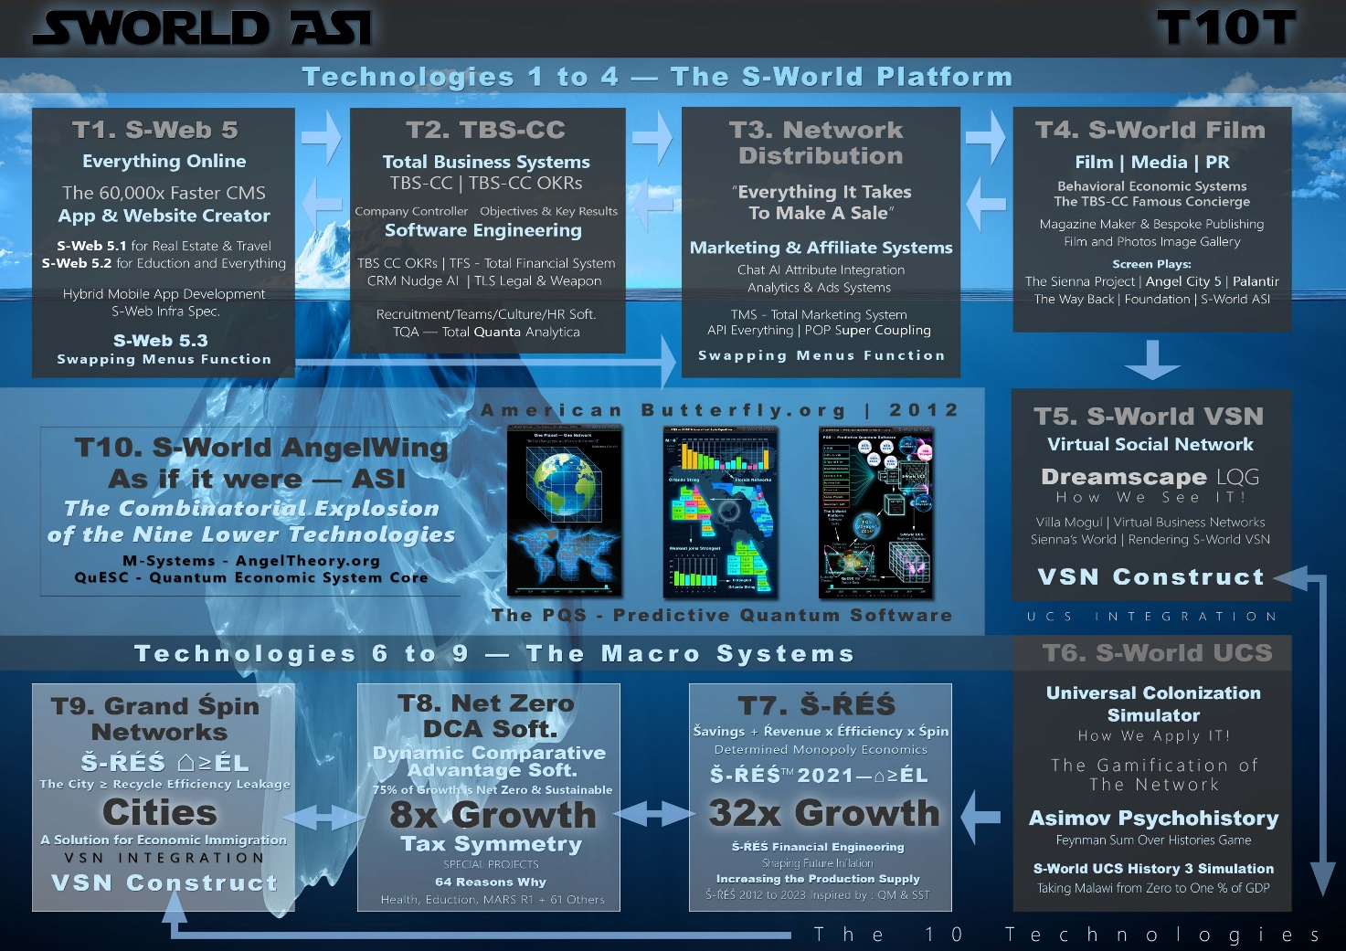
These futuristic designs have been developed over 13 years, always with a crucial component missing – advanced AI, like GPT-4. Our goal isn't to create an AI that rivals the tech giants; instead, we aim to utilize AI, like GPT-4, as a collaborative force in realizing our long-envisioned ideas. The integration of AI is the key to bringing S-Web 6VC🚀 AI-CMS to life, not just as a tool, but as an integral part of our innovative venture."
In our quest for technological innovation, we're not just aligning with one AI provider. Our approach is to harness the best AI through a microservices system, allowing us to swap tools as better ones emerge. Take, for instance, our GP-AI within the ALL COMMS system, part of our Technology 10 suite. Here, we're leaning towards OpenAI's GPT, primarily for its unmatched language processing capabilities. My familiarity with GPT and its reputation as a leading language AI makes it an ideal choice for integrating into S-Web 6VC🚀 AI-CMS. However, this isn't a one-size-fits-all solution. We can incorporate other AI technologies for different microservices, tailoring each to suit specific functionalities. This flexible approach ensures our system remains cutting-edge, adaptable, and not confined to the offerings of just one AI provider.

1. Reinventing the Internet. Internet 4.0 The Website is the Business

In our digital journey to Internet 4.0, we're witnessing a revolutionary change in how websites are perceived and utilized in business. The evolution began with Internet 1.0, the early stages of the web, where websites were mere information portals. Then came Internet 2.0, marked by the rise of social platforms like Facebook, transforming the web into a space for social interaction and content sharing.

The advent of Internet 3.0, the Semantic Web, brought a profound leap, integrating interconnected data and AI to create smarter, more engaging online experiences. This phase laid the groundwork for AI's role in enhancing digital interactions, setting the stage for what was to come next.

Now, we enter Internet 4.0, where the concept of websites undergoes a radical transformation. Here, websites are no longer just online representations of businesses; from a certain point of view, they are the businesses themselves
This paradigm shift means that every aspect of a business's operations, from legal and accounting processes to customer service and logistics, is embedded within the website. This comprehensive integration signifies a new era where managing a business becomes as intuitive as navigating a website.

Imagine a system where updating your website simultaneously updates your business operations. Need to rearrange staff schedules? It's just a click away on your site. Managing finances or paying taxes becomes a seamless part of your online dashboard. This level of integration is made possible by leveraging the advancements in cloud computing and microservices, provided by platforms such as Azure, AWS, Google Cloud Platform (GCP), and IBM Cloud. These platforms offer the necessary tools and infrastructure to create such sophisticated, integrated systems.

In this new world of Internet 4.0, creating a website using our system is akin to laying the foundation for an entire business ecosystem. Unlike traditional platforms like WordPress, which simplifies website creation, our approach offers a deeper level of integration. It's about creating a digital nerve center for your business, capable of evolving and adapting to your operational needs.

This future-oriented vision is not just a technological leap; it's a reimagining of digital business operations. It democratizes access to advanced business tools, allowing small and medium-sized businesses to harness the same level of sophistication and integration that was once the reserve of larger corporations. By simplifying complex processes and embedding them into the digital fabric of a website, we're opening up a world of possibilities for businesses of all sizes.

In summary, Internet 4.0 represents the culmination of years of digital evolution, bringing together the advancements of the past and the possibilities of the future. It's a testament to the power of technology to transform how we do business, making it more efficient, integrated, and accessible to everyone.

2. How Does Everybody Make Money? [SWF Network Effects]
In our innovative revenue model, a real-world example best illustrates its effectiveness. The last time we implemented this, a client paid $100,000 for a safari through ExperienceAfrica.com. This transaction generated a $20,000 commission, equally shared between ExperienceAfrica.com and the referring company, CapeVillas.com. From each of their $10,000 shares, a 12.5% fee on the commission, totalling $1,250, was contributed to S-World. Consequently, the total revenue earned by S-World from this single transaction amounted to $2,500, representing 2.5% of the original $100,000 payment.

(Retrospective insert on 12th of July 2024, I'd forgotten!
The highlight event within the S-Web SMF $100,000 safari booking was Ulusaba, Sir Richard Branson's private game reserve in Sabi Sabi, South Africa
This is not only useful for this document, but for all documents, in case anyone was dubious about whether that actually happened, $10,000 for a single referral may sound like fantasy to some.
This additional info the name of the supplier as Limited Edition added to the 9 training videos I made of process shows that this genuinely happened. This booking was proof of concept in a big way. The transaction that inspired the concept of the swapping menus function - as the main ‘money maker’ within S-Web 6 VC AI CMS and maybe even future S-World HEAI. (Human Economic AI)

This model showcases how our system effectively facilitates connections between buyers and sellers, creating a win-win scenario for all parties involved. By charging a modest percentage of the total transaction value, it ensures a sustainable revenue stream for S-World and provides an attractive, profitable platform for sellers and referrers. This approach represents an advanced and efficient way to monetize the facilitation of transactions in the digital marketplace, proving especially beneficial in high-value transactions like luxury safaris.

2A: The 🔁📑⚛️ SWF: Swapping Menus Function.

The Swapping Menus Function (SWF), as demonstrated in the successful transaction by Cape Villas, represents a pivotal innovation in digital commerce. At its core, SWF enables businesses like Cape Villas to diversify their offerings, as seen in their dedicated safari menu (www.capevillas.com/Best-of-Africa). This functionality was expanded upon by its creator, Nick Ray Ball, envisioning a system where a website could offer a multitude of services through an extensive menu system.

This concept evolved to allow for potentially thousands of services and products to be offered on a single website, organized through an intricate system of main menus and submenus. This approach significantly increases the range of offerings a business can present, from primary products to auxiliary services like legal advice, car hire, and more.

Moreover, the integration of AI, specifically GPT-4, into this system marks a further advancement. It shifts the interaction from traditional menu navigation to AI-driven conversational interfaces, where customers can access a vast array of services through natural language dialogue. This AI integration promises to streamline the user experience, making it more intuitive and responsive to customer needs.

The evolution from the initial creation of the affiliate menu system to the streamlined process in S-Web 6 VC🚀 AI-CMS🌌 is a testament to technological advancement and innovation. Originally, it took Nick Ray Ball a decade to develop the systems that yielded significant affiliate revenue. Implementing such a system traditionally, even with basic CMS tools, involves hundreds of hours of labour, not to mention the continual updates and need for real-time API integrations.

In stark contrast, S-Web 6 VC revolutionizes this process. What once took years to conceptualize and implement can now be achieved in mere seconds. By simply using a voice command to include services like safaris, the system automatically integrates these offerings into the menu. This capability isn't just limited to one service; it extends to a wide array of services, streamlining what was once a labour-intensive process into an effortless, user-friendly experience. This innovation dramatically reduces the time and effort required, making sophisticated affiliate marketing accessible to all users.
Retrospective comment on the 12th of July 2024, the following was the inspiration for the Sienna AI ad. This is cool, it makes this document all the more relevant, but to be clear the way it's written sounds like we have already engineered this. Last week I used GPT4 to generate a Python command in Azure to read out loud, it was a lot easier than I thought and can be engineered.

To be clear - if you turn on the S-Web app, say “Sienna, I think we’ll add safaris this week.”
That’s that – What used to take teams days, months and years can now be done in less than 5 seconds, verbally without having to press a key.

The 🔁📑⚛️ SWF: Swapping Menus Function 2: The Future of Search

The future of search is poised for a significant transformation. Increasingly, people are turning to search engines not just to find specific websites, but to get direct answers to their questions. This trend is becoming more prevalent, particularly as giants like Google and Microsoft integrate more advanced search capabilities into their browsers. We're already witnessing the beginnings of this shift with platforms like Bing and Google, where search is evolving to be more intuitive and conversational, reflecting a deeper integration of AI and user intent in the search process.
We believe that the future of search, or SEO as it is often called, hinges on the training data of AIs and the frameworks enabling Large Language Models (LLMs) like GPT to communicate effectively. Initially, I thought the training data for GPT consisted solely of the books it had 'read', but the reality is far more extensive. The training data encompasses a vast array of digital texts, including websites, articles, books, and other diverse written materials. This comprehensive database is crucial as it teaches the AI about various aspects of human language, helping it understand and emulate human-like text interactions."
This expanded understanding of training data underlines its pivotal role in shaping how AI interacts and responds in a wide range of scenarios, forming the foundation for effective search and SEO strategies in the future.”
By entangling website content and functionality - especially the SMF 🔁📑⚛️ Swapping Menus Function, with AI we hope all products will become integral to the training data, not just for S-World and S-Web but for all searches. across the Internet.
How much this will come true will be evidenced in the years to come, it's a theory.
"But what isn't a theory is the envisioned capability of the SMF 🔁📑⚛️ Swapping Menus Function within the S-Web AI-driven platform. This proposed functionality aims to collate all products on the network, integrating them into AI-powered conversations with customers. The AI, empowered by the future implementation of the Swapping Menus Function, will be designed to intuitively understand customer queries, using keywords to recommend relevant products and services. This approach reflects our commitment to transforming customer interaction, making it more dynamic and responsive.

Our goal is for the Swapping Menus Function to evolve into a core component of the AI's training data. This development would intertwine the vast array of products in our network with the AI's operational framework, enhancing the system's utility and its potential to generate revenue. This alignment is crucial for the economic model of our system, offering significant benefits for both users and stakeholders and establishing the Swapping Menus Function as an integral part of our digital ecosystem."

2B: The Instagram Example
Using the real-world context of Colleen Rooney's Instagram account, as depicted in "Vardy v Rooney: A Courtroom Drama" (Channel 4) and "The Real Wagatha Story" (Disney Plus), we can explore the potential for monetization on private social media accounts. Colleen's account, initially created for close friends and inadvertently becoming a platform for friends to promote their products, sets an interesting precedent. This scenario showcases how personal social networks can evolve into opportunities for genuine, friend-supported commerce.

The theoretical integration with Instagram would enable users like Colleen to effortlessly turn their social connections into an e-commerce network. With S-Web's system, such users could support their friends' businesses and also generate revenue for themselves, all within the comfortable and familiar environment of their private social media accounts. This concept isn't just a theoretical musing; it's a potential pitch to Instagram, showcasing how their platform could facilitate new forms of social e-commerce, transforming personal connections into profitable networks.

2C. The Airbnb Example

We are keen on partnering with Airbnb, a connection we might establish through Peter Thiel’s VC Founders Fund, a stakeholder in Airbnb. This approach is partly inspired by Thiel's "Zero to One," a book that profoundly influenced my understanding of monopolies. This understanding paved the way for developing T7. Š-ŔÉŚ, a model centred on maximizing network cash flow through efficient recycling and reinvestment within the network. This concept underpins our ambition to exponentially increase the economic impact for network-connected businesses, a strategy we're implementing through our technological innovations.

I believe Thiel would find the T7. Š-ŔÉŚ concept fascinating, particularly due to its role as a facilitator of Technology 3, Networks Distribution, whose core principle, "Everything needed to make a sale," resonates with Thiel's insights in "Zero to One." The integration of the Swapping Menus Function within Technology 3 is crucial for enhancing network effects. It's this innovative combination that we hope will inspire a recommendation for Airbnb to consider collaborating with us on this groundbreaking project.
The Airbnb Plan involves introducing S-Web Platform technology to Airbnb hosts. This innovative approach would enable every Airbnb property owner to have their own dedicated website. More than just showcasing their property, these websites would allow hosts to also resell other Airbnb properties, creating a network of interconnected listings. Additionally, they could offer various products and services from the broader network, ranging from insurance to safaris, catering to a wide array of customer needs. This plan aims to transform individual Airbnb listings into comprehensive e-commerce platforms, significantly expanding the earning potential of hosts.
Based on an estimation, there are around 3.5 million unique Airbnb users. If even a fraction, say one in 3.5, opts to create their own website through the S-Web platform, this could potentially result in about a million new, dedicated websites. These sites wouldn't just be simple listings; they'd be comprehensive platforms where hosts could also resell other Airbnb properties and various products from the broader network. This strategy would not only transform the way Airbnb properties are marketed but also expand the business scope for individual hosts, turning them into affiliates within a larger e-commerce network.

Incorporating the real-world example from CapeVillas.com, we can demonstrate the potential of this model. Previously, CapeVillas.com successfully referred a client to ExperienceAfrica.com for a safari, resulting in a significant transaction. This referral led to a commission of $20,000, split evenly between the two companies. CapeVillas.com earned $10,000 from this single referral. This example is a practical demonstration of how hosts, similar to those on Airbnb, could generate substantial income by effectively utilizing the proposed S-Web platform, not just for property rentals but also by selling additional services and products.

The envisioned transformation of Airbnb's network into a comprehensive e-commerce platform is striking. Imagine a scenario where a million individual websites, each belonging to an Airbnb host, serve as gateways to a myriad of products and services. These sites wouldn't be limited to property rentals; they could offer everything from hotel bookings to car rentals and unique local experiences. Key to this is the integration with various APIs and Global Distribution Systems (GDS), allowing hosts to earn commissions ranging from 20% to 50% for every booking made through their site. This system exemplifies the essence of S-World's functionality – a powerful, interconnected affiliate marketing network that goes beyond mere property rentals, granting access to a global market of goods and services.

2D. The Sotheby's International Realty Example

Sotheby’s 2010 – S-Web 2.0
The partnership between CapeVillas.com and Sotheby's International Realty Cape Town in 2010 marked a significant milestone, catalyzing the S-Web concept. This collaboration was initiated following the successful launch of the Cape Villas magazine, distributed alongside Condé Nast Traveller UK. The magazine's impact was notable, attracting the attention of prestigious brands like Bulgari and leading to various collaboration inquiries. This venture with Sotheby's not only underscores the potential for strategic partnerships but also highlights how innovative marketing approaches can open doors to new, influential business relationships.

In 2010, while developing the first version of Experience Africa (S-Web 2.0), we faced a setback. The Silver Sphere team, lead engineers for S-Web 1.2 disbanded in 2007, preventing us from continuing with that system. Consequently, we initiated a new project with a different team. The result was a visually appealing website, but the CMS was not as robust as needed. Sotheby's then approached us to replicate the ExperienceAfrica.com website for their use, under the title 'African Concierge.' The graphic below illustrates two pages from Experience Africa and one from Sotheby’s African Concierge, highlighting the similarities in everything but design and branding.

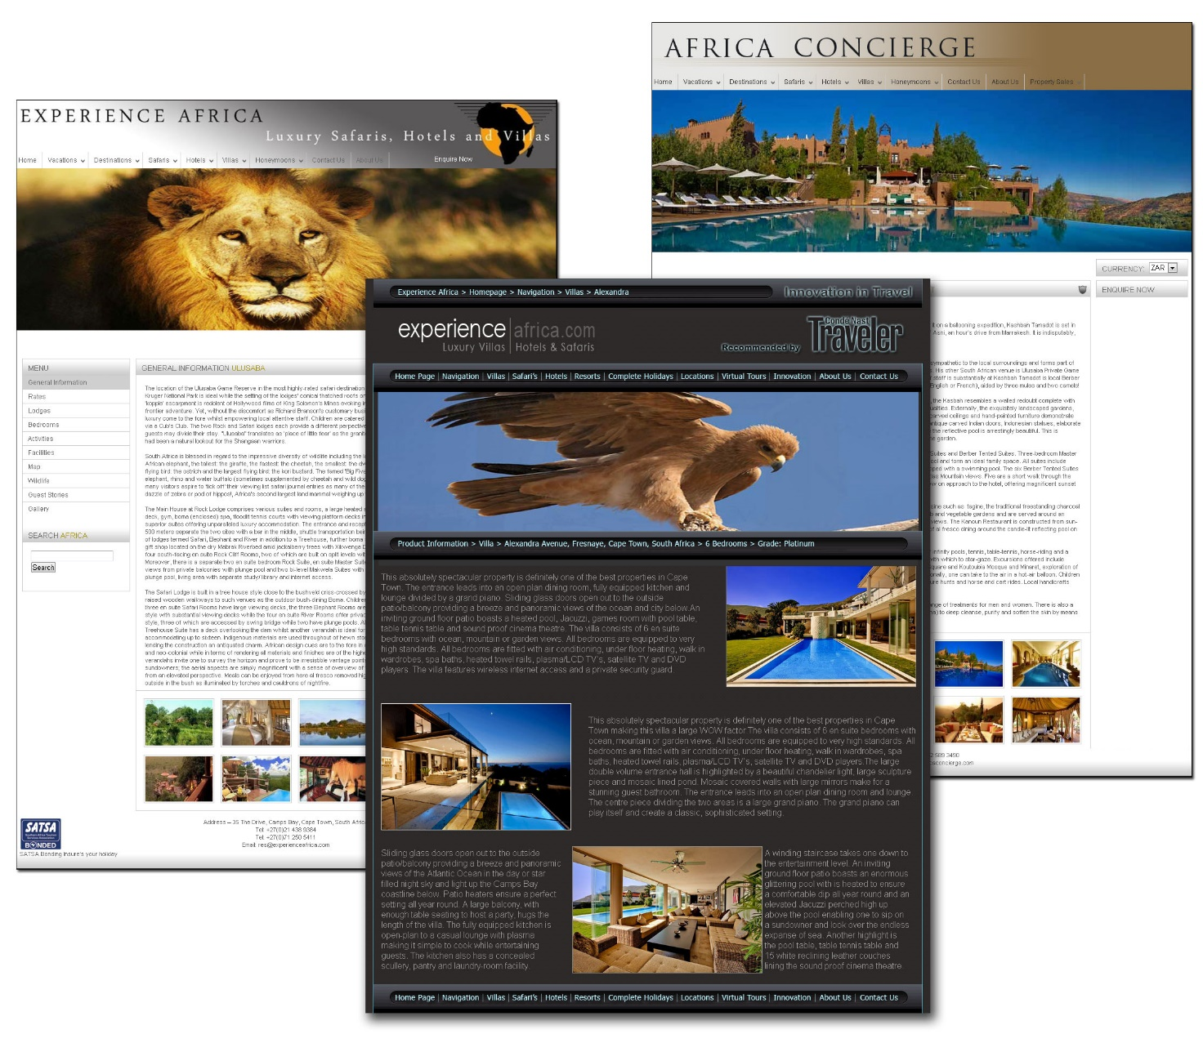
The collaboration with Sotheby’s International Realty for African Concierge was a pivotal experience, driving the evolution of S-Web. It became clear that my direct involvement in the development process was crucial. This realization led me to embrace a DevOps role, blending development with operational testing to ensure robust and functional systems. The concept of S-Web matured significantly during this phase, laying the groundwork for future presentations and collaborations, such as the one with Virgin Brands SA in 2011. This experience underlined the importance of a hands-on approach in technology development, especially when it involves intricate web platforms like S-Web.
In 2013, undeterred by previous challenges, I firmly reestablished myself in a DevOps role. Partnering with a PHP programmer from India, I embarked on a crucial project to recreate Cape Villas, leading to the inception of Villa Secrets and the development of S-Web 3.0. This time, I was deeply involved in every aspect of the development, from designing to collaborating closely with the programmer. This hands-on approach ensured that the vision for S-Web 3.0 was realized without the setbacks experienced in previous versions, marking a significant step in the evolution of our technology.

Sotheby’s 2024 - S-Web 6VC🚀 AI-CMS
"In 2024, we see Sotheby's International Realty as a significant potential partner, with their expansive network of 11,000 agents worldwide. Each agent, by transforming up to 100 property listings into individual websites using S-Web technology, could collectively contribute to over 1,100,000 property-specific websites. These sites are envisaged as more than mere property showcases; they're designed to evolve into comprehensive e-commerce platforms. The goal is for each website to become a lasting repository for its respective property, gathering detailed historical records, architectural plans, and other significant data over time. Such a dynamic approach encourages property owners to actively participate in enriching the site's content, fostering a sense of continuous involvement and investment in the property's virtual representation.

Moreover, this strategy aims to ensure the continuity of the real estate broker's involvement, even as property ownership changes hands. The consistent use of the same website for successive transactions can potentially retain the same broker, thereby maintaining a stable, ongoing business relationship. The integration of virtual reality elements, such as a potential connection to Oculus through a dedicated microservice, further enhances this experience. This incorporation of virtual elements harks back to our early innovations in virtual tours with the S-World VSN technology. This comprehensive, interactive approach to real estate marketing and mandates is not just about showcasing properties; it's about creating value-added, engaging experiences for both buyers and sellers."

Mandates
Mandates are vital in both industries; once a mandate is secured, it becomes the start of an affiliate sale, with other real estate companies selling the property and splitting profits with Sotheby's. S-Web 5 and the upcoming S-Web 6 promise to significantly boost mandate acquisition, offering innovative strategies beyond websites, extending into print marketing and more. This approach could be highly appealing to Sotheby's International Realty, and because they have a UK subsidiary, they become an ideal partner for the Innovate UK opportunity, where the UK government provides 70% of the funding up to £2,000,000 for winning applications.

2E: Peter Theils' Zero to One - Chapter 4 - Characteristics Of Monopoly Summary & Network Effects
Peter Thiel's "Zero to One" Chapter 4. discusses the characteristics of a monopoly, focusing on aspects like proprietary technology, network effects, economies of scale, and branding. He emphasizes that these are not just checkboxes for business success but are critical considerations for building a durable monopoly. Key insights include:

Proprietary Technology: A unique tech advantage makes a product hard to replicate, as seen with Google's search algorithms.

Network Effects: The value of a product increases as more people use it, but it must be valuable from the start, even to a small user base.

Economies of Scale: Growth strengthens a monopoly, especially in software where the marginal cost of production is low.

Branding: Creating a strong brand is powerful, but it must be backed by substantial underlying advantages like proprietary tech and scale.

Network Effects [complete quote]
“Network effects make a product more useful as more people use it. For example, if all your friends are on Facebook, it makes sense for you to join Facebook too. Unilaterally choosing a different social network would only make you an eccentric.
Network effects can be powerful, but you’ll never reap them unless your product is valuable to its very first users when the network is necessarily small. Mark Zuckerberg’s first product was designed to get all his classmates signed up, not to attract all people of Earth. This is why successful network businesses rarely get started by MBA types: the initial markets are so small that they often don’t even appear to be business opportunities at all.”

2F: THE 2500x Jump from Airbnb to All GDP And Used Good Sales

In all use cases above, we’re creating a large network of websites, each of which is an e-commerce platform, and each of which when employing the microservices can run the business. This returns us to Part 1 where we say “We're reinventing the Internet where instead of a business having a website, the website is the business,” or more to the point the website provides everything the user needs to run that business, as a sole proprietor if one wished. The technology is designed to give the sole proprietor the power to compete with big business. Or allow the sole proprietor to become an SME and if it is destined a big public company.

"Consider the transformative potential of applying our approach to examples like Instagram, Sotheby's, or particularly Airbnb. Imagine an legal company realizing the immense value of joining our expansive network. They could introduce a specialized legal service, leveraging S-Web's capabilities. This anticipation isn't just conjecture; we're actively developing legal services (The TLS & TLS-W) as a prototype industry within S-web. The realization of such integrations could extend across various sectors. Consequently, this could shift the focus from the modest 0.5% of GDP commanded by vacation rentals to encompassing the entirety of GDP, marking a staggering 2000-fold expansion of market opportunities for each website in our network."

💡 A fascinating revelation about revenue potential: it actually exceeds a 2000x increase when we consider second-hand sales. In GDP calculations, only new goods are counted, but the addition of second-hand items – like properties, cars, yachts, trains, computers, and phones – significantly boosts our potential market. These second-hand goods might represent about 25% more than the traditional GDP figures. So, when we shift from the limited scope of holiday rentals, which constitute a mere 0.5% of GDP, to encompassing all goods and services along with second-hand sales, we're looking at a staggering potential increase of 2500 times. It's an eye-opening expansion from holiday rentals to the entirety of economic transactions!
In this expansive network, the websites are not confined to showcasing, Sotheby’s International Realty properties, Instagram account users goods and services, or Airbnb vacation rentals. Users have the freedom to brand and rename their sites as they wish, offering the flexibility to evolve and adapt their digital presence. The capability to own multiple, diverse websites further enhances this adaptability.
Crucially, these websites are just the beginning. They serve as a foundation for developing applications interconnected through a sophisticated system of microservices. These microservices not only work in harmony with a range of AI technologies and the best-existing tech solutions but are also designed to seamlessly integrate emerging technologies, replacing outdated ones. This continuous evolution and integration are pivotal, leading us into the realms of modern software engineering and microservices, which will be our focus in the upcoming section 'T2. TBS-CC OKRs 🌀DevOps 🌀 4.6 & The QA ⚛️🔍 Quanta Analytica'."

3. T2. TBS-CC OKRs 🌀DevOps 🌀 4.6 & The QA ⚛️🔍 Quanta Analytica

So much has gone into TBS-CC OKRs 4.4.4, and 4.5 which work with teams and individuals. When it comes to transitioning to DevOps I'm hoping David Farley the author of Modern Software Engineering and Nicole Forsgren, Jez Humble, and Gene Kim the authors of The State Of DevOps Reports, & Accelerate will set the parameters that create scores in ingenious and fun ways that encourage and reward engineers for applying DevOps, TDD, and Continuous Delivery techniques and practices.

Since writing the above, a lot has happened in this space.

https://podcasters.spotify.com/pod/show/nickrayball/episodes/2-DF-54-OKR-DevOps-e2lbhmq

ℏ🚀🌀💙
Nick Ray Ball

S-Web 6VC🚀— AI CMS
2002 to 2024

S-Web 6 VC🚀 | V🌀N

S-Web 6 VC🚀 ‘Sienna’ AI CMS 🌀

Nick Ray Ball
Founder
S-World HEAI LIMITED UK
www.S-World.org
Company Number 14929119
Wren House, 5 Elm Grove, Epsom, Surrey, KT18 7LZ

Contact
+44 7387 394 298

S-World HEAI by Nick Ray Ball
1999 to 2024

